1:CREDIT CARD PROCESSING SYSTEM

USE CASE DIAGRAM:

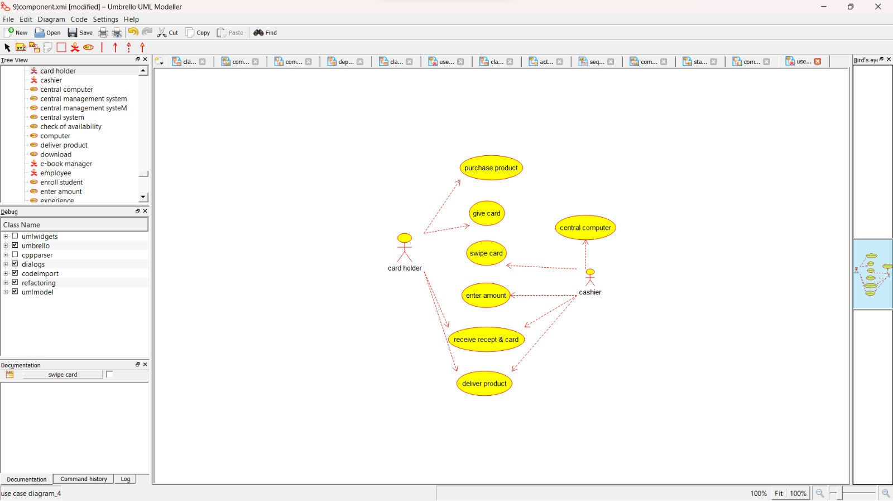

CLASS DIAGRAM:

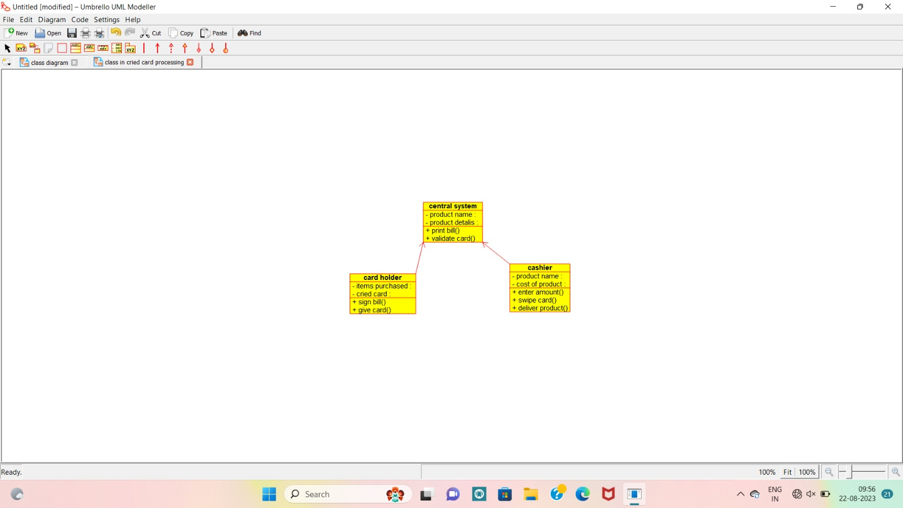

ACTIVITY DIAGRAM:

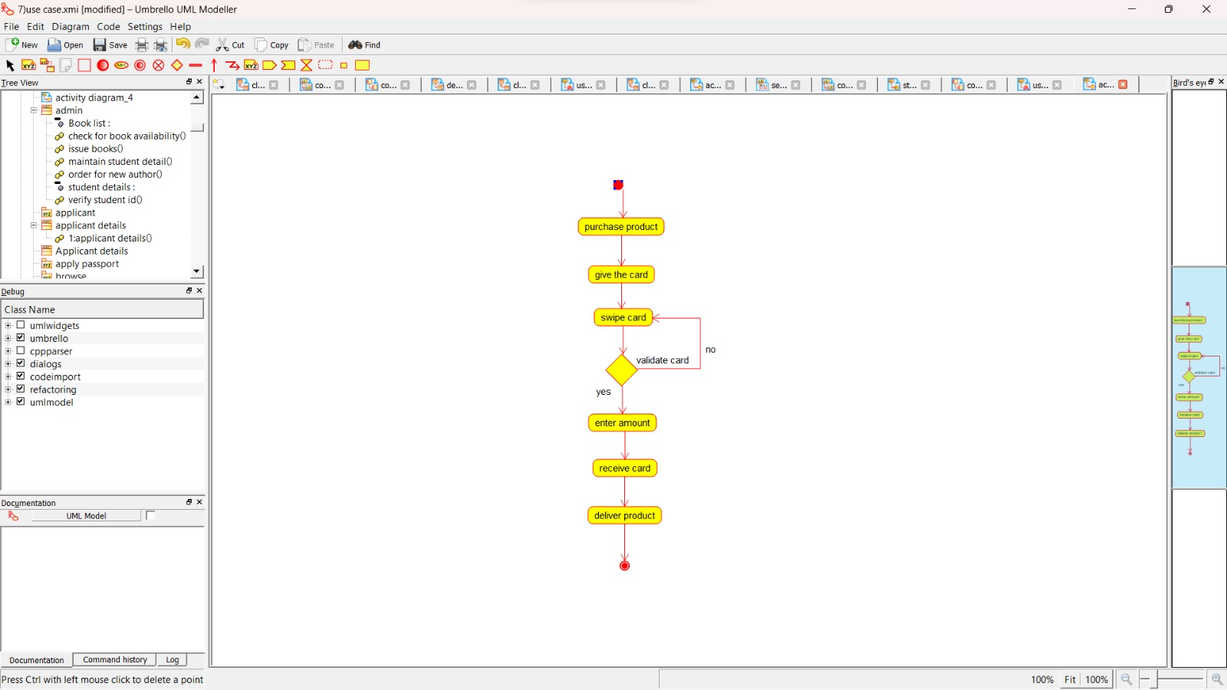

SEQUENCE DIAGRAM:

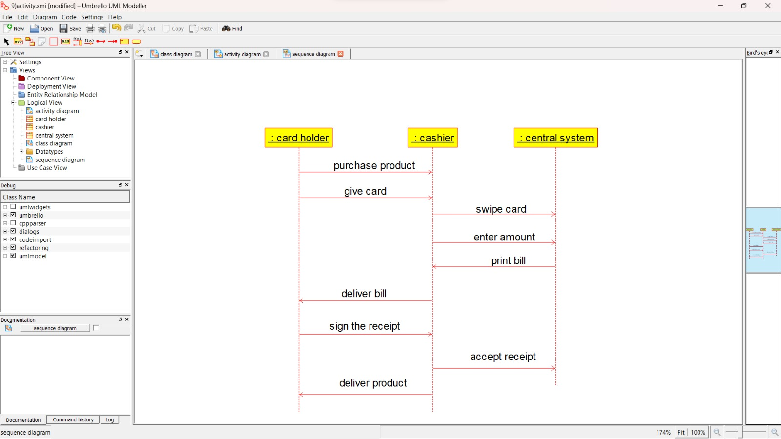

COLLABORATION DIAGRAM:

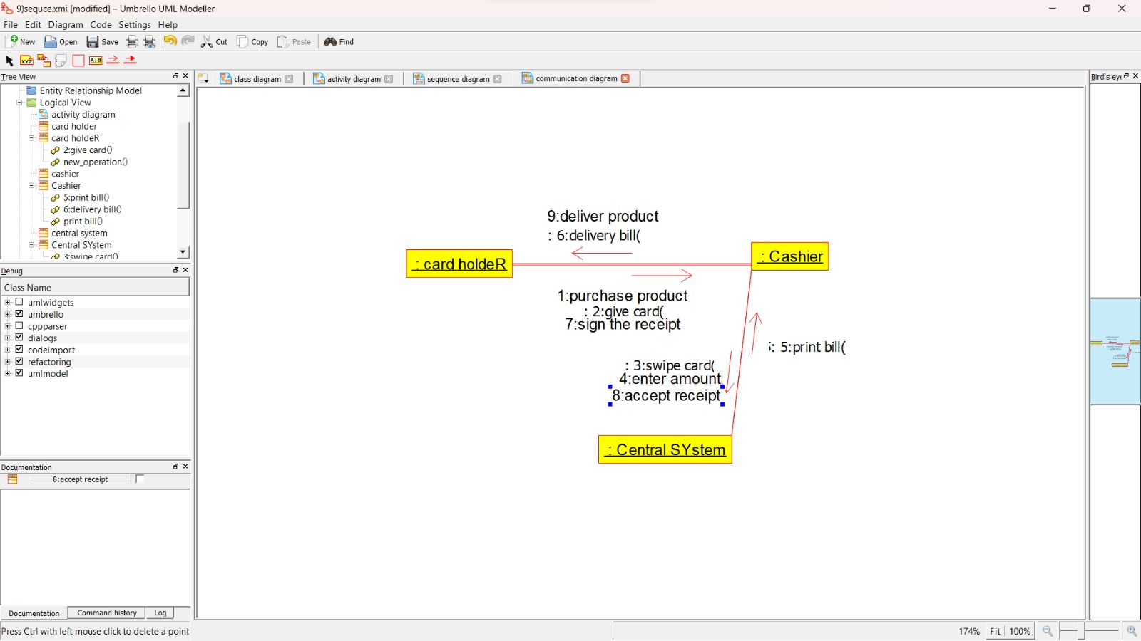

STATE CHART DIAGRAM:

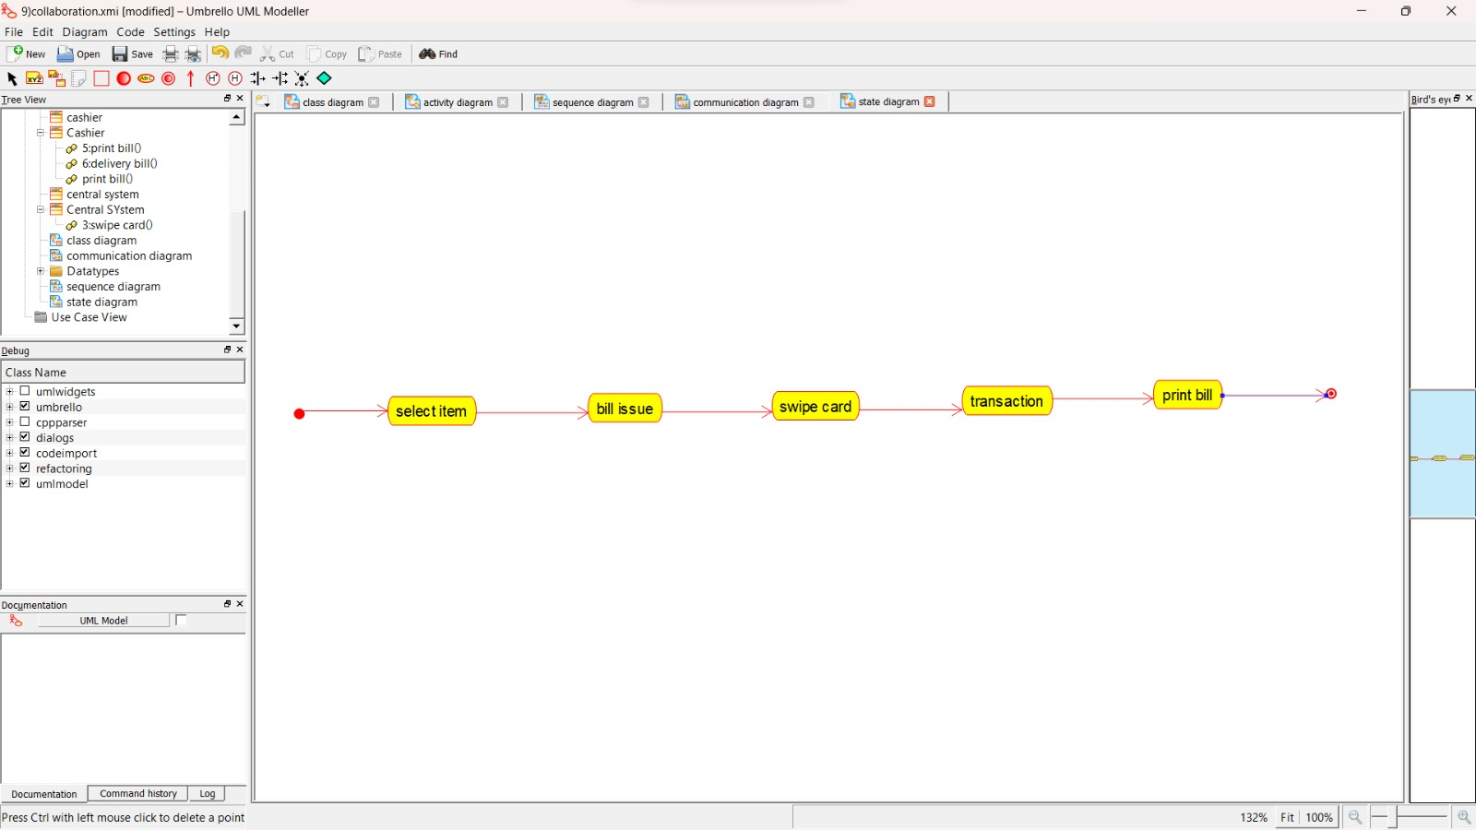

COMPONENT DIAGRAM:

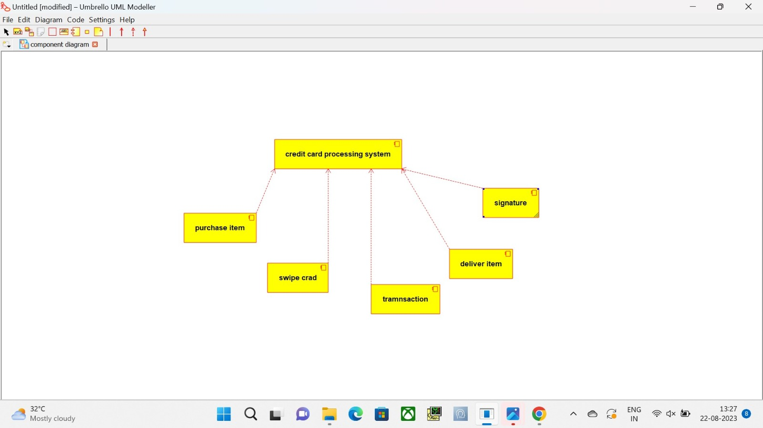

DEPLOYMENT DIAGRAM:

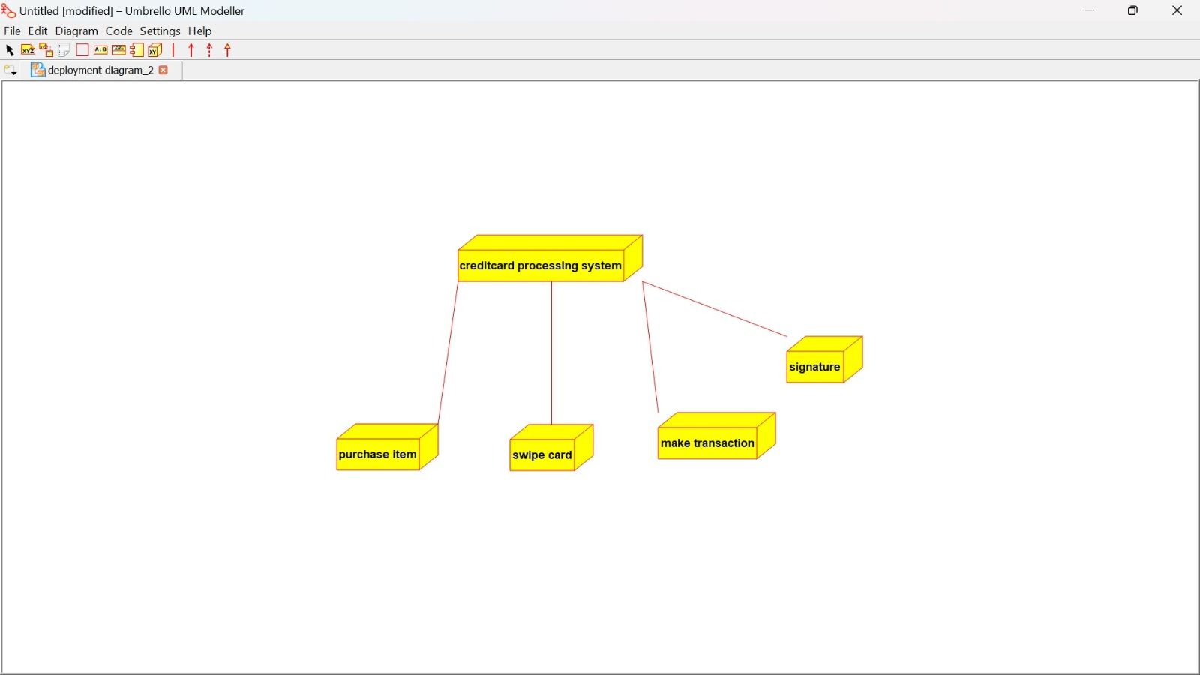

PACKAGE DIAGRAM:

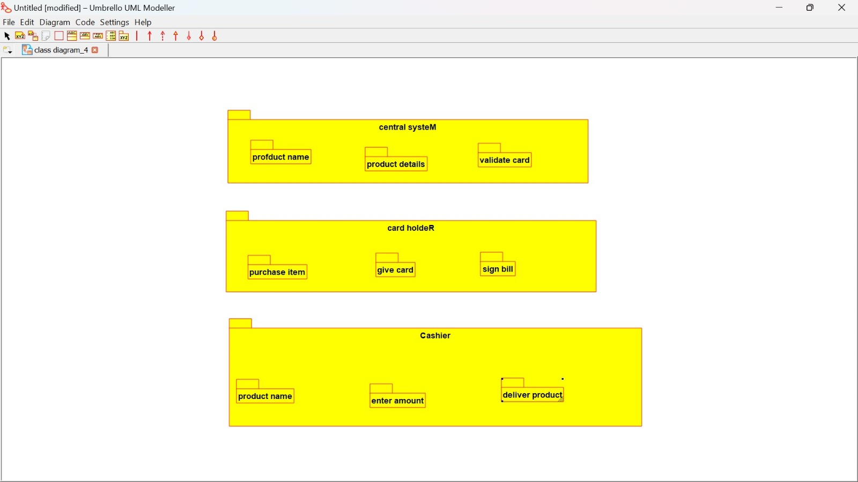

2:SOFTWARE PERSONNEL DEVELOPMENT

USE CASE DIAGRAM:

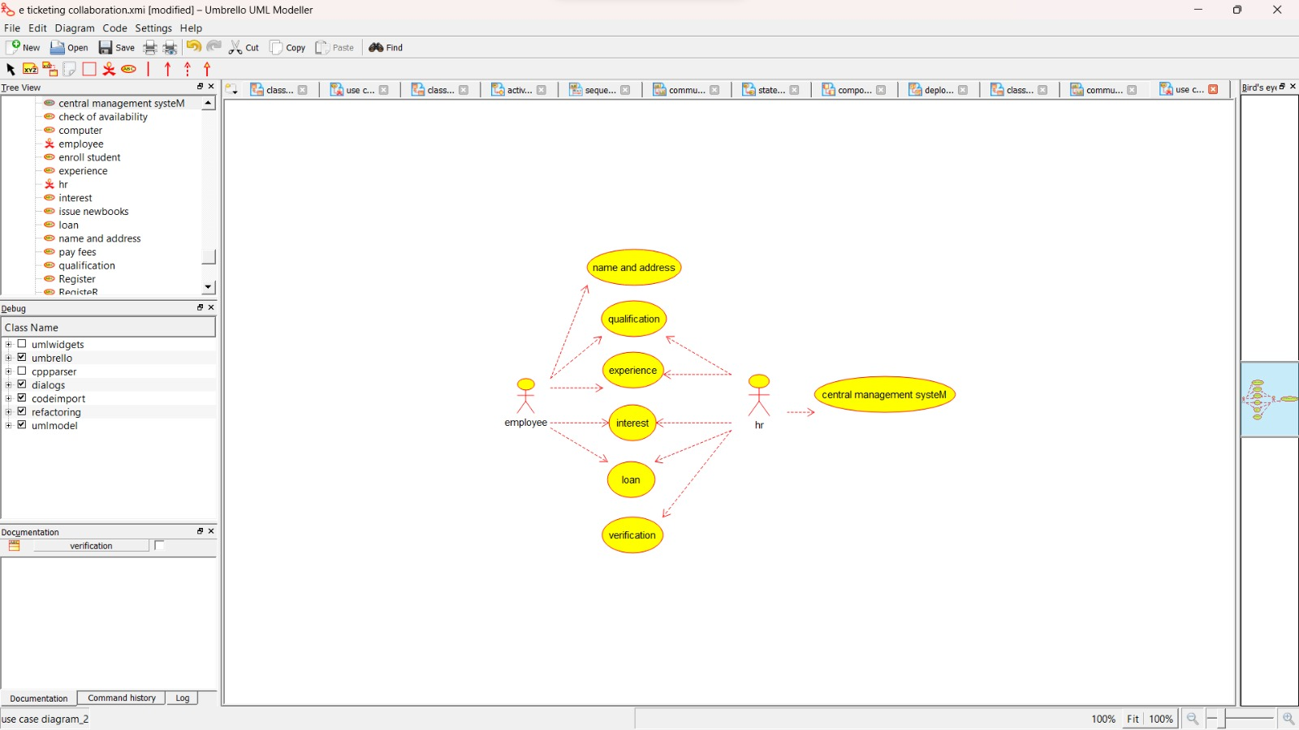

CLASS DIAGRAM:

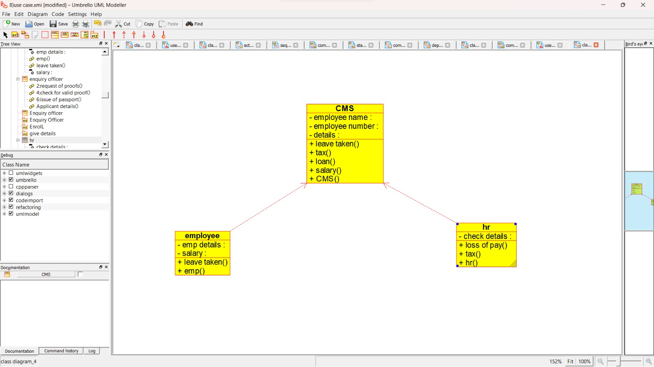

ACTIVITY DIAGRAM:

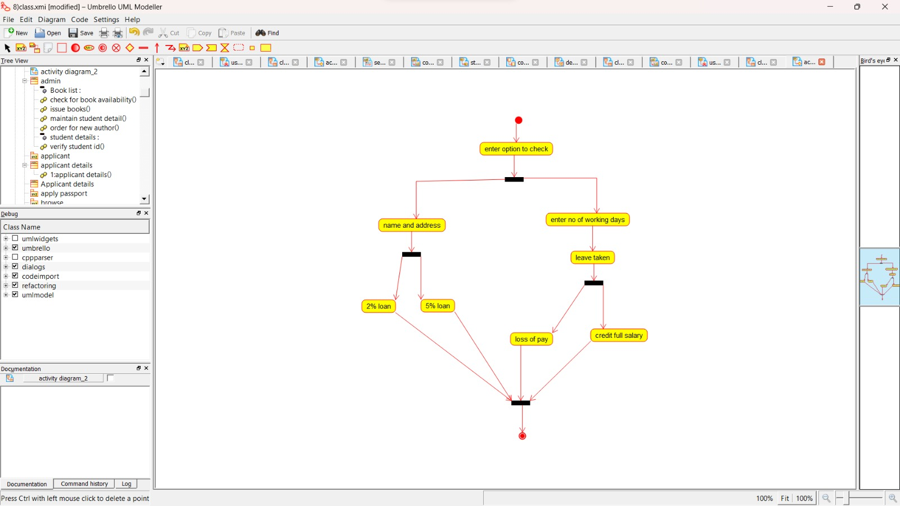

SEQUENCE DIAGRAM:

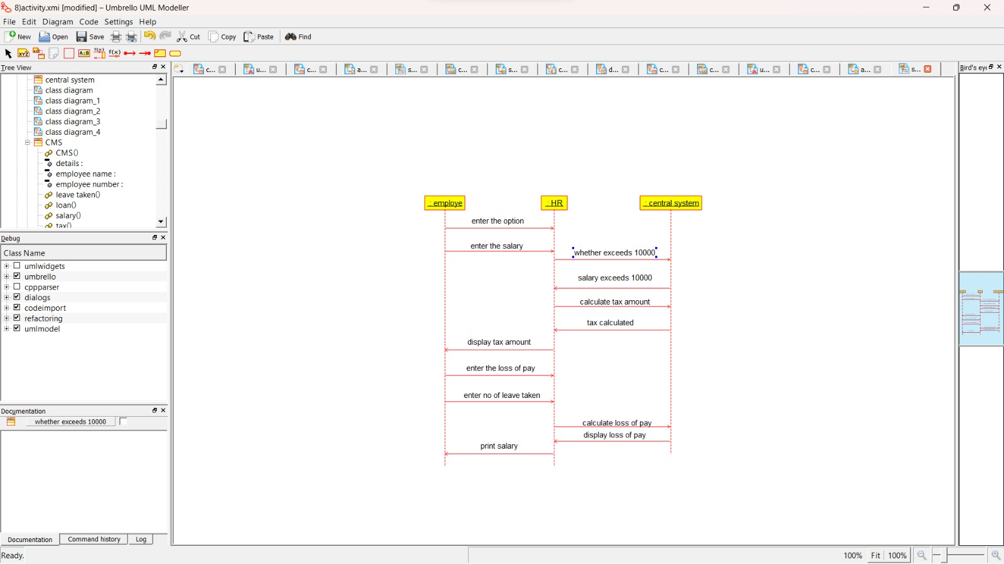

STATE CHART DIAGRAM:

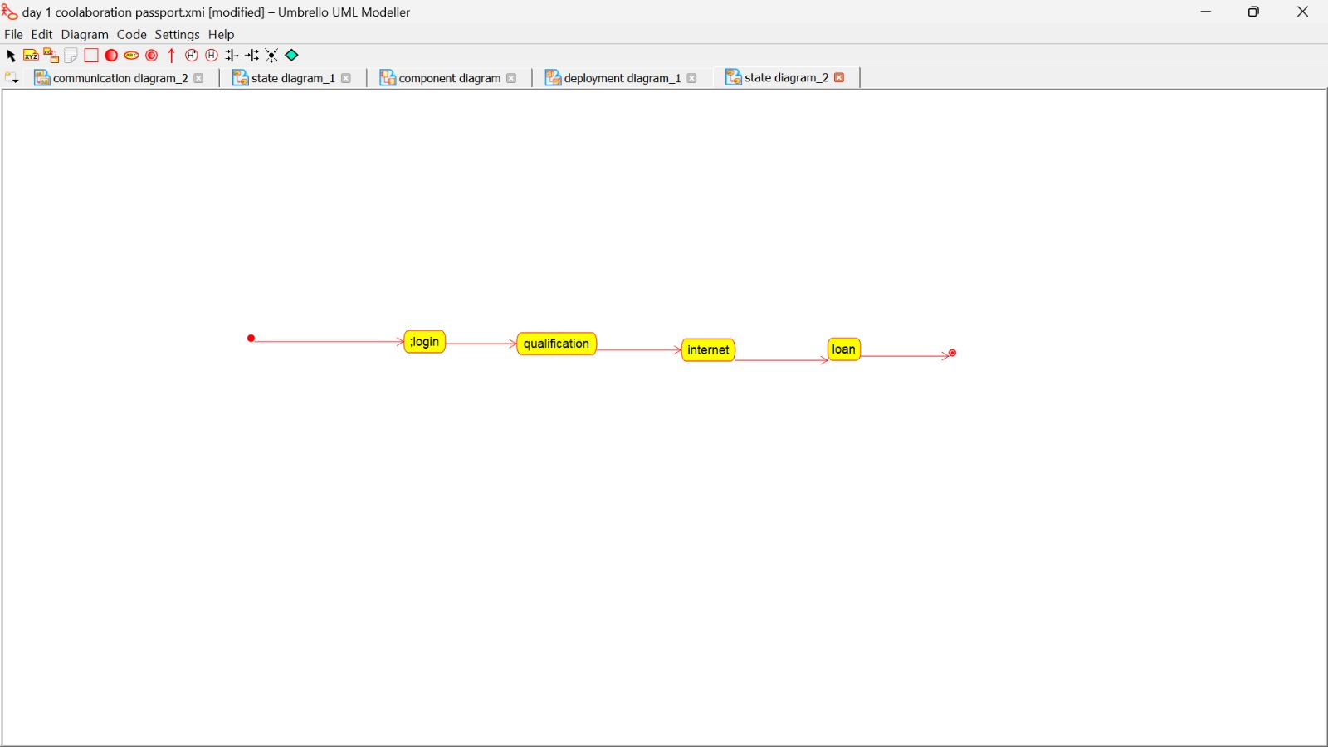

COLLABORATION DIAGRAM:

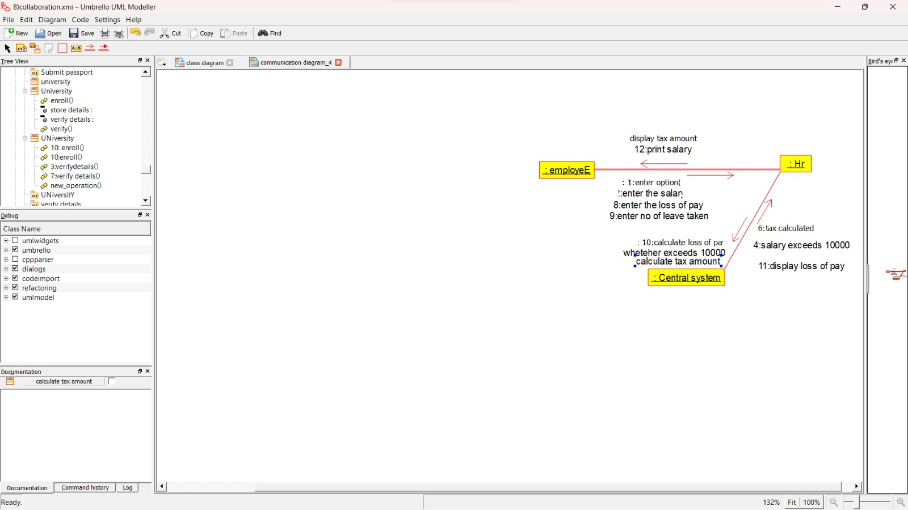

COMPONENT DIAGRAM:

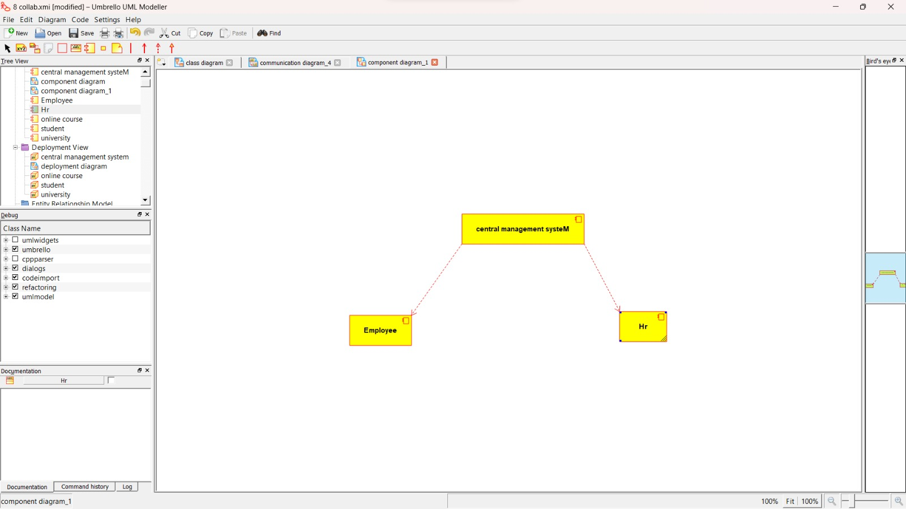

DEPLOYMENT DIAGRAM:

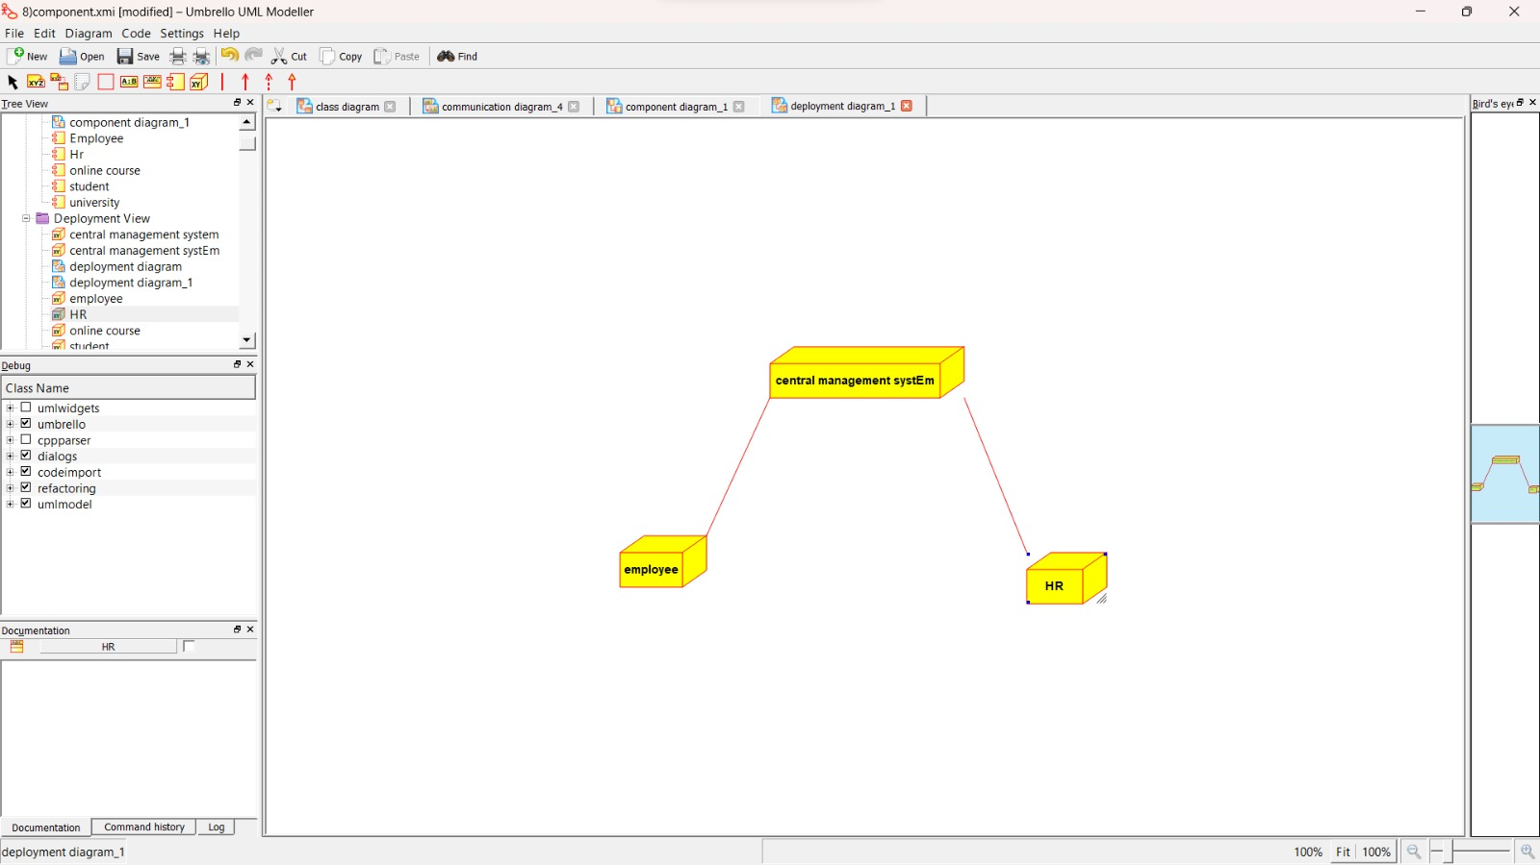

PACKAGE DIAGRAM:

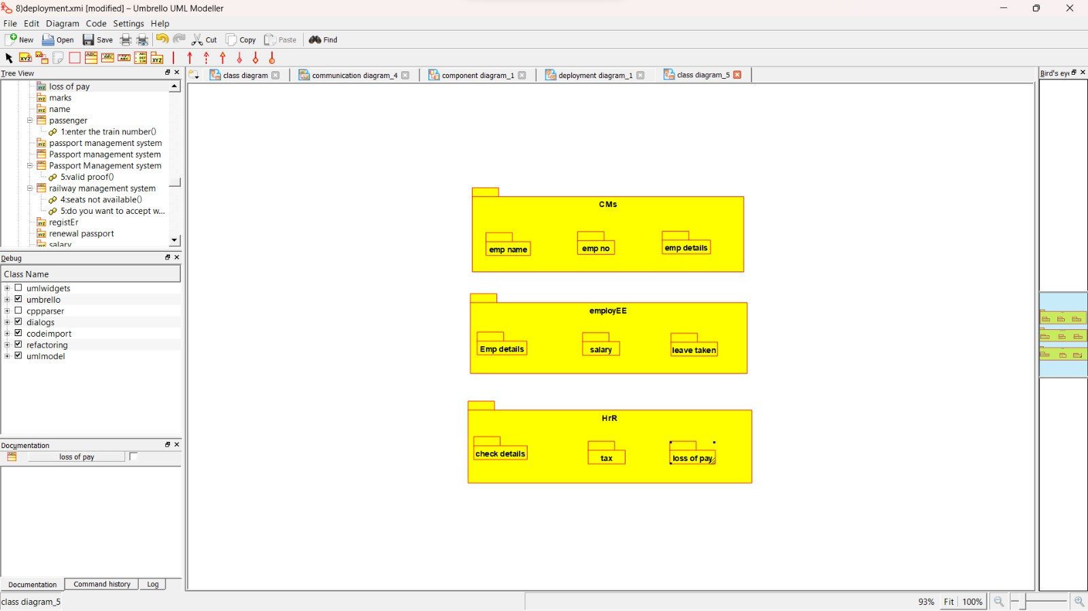

3:E –BOOK MANAGEMENT SYSTEM

USE CASE DIAGRAM:

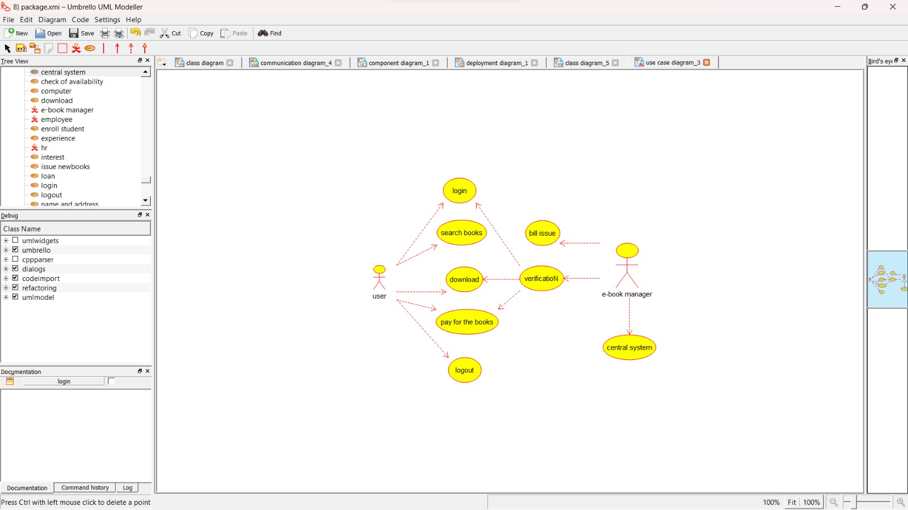

CLASS DIAGRAM:

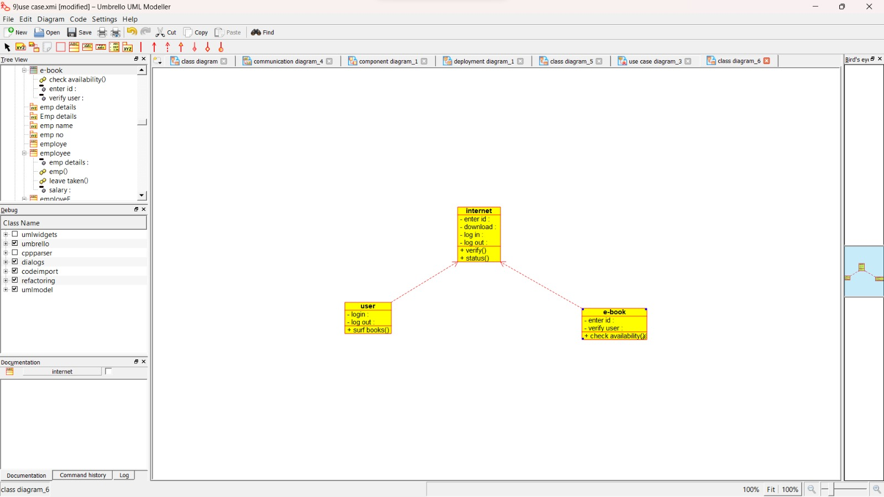

ACTIVITY DIAGRAM:

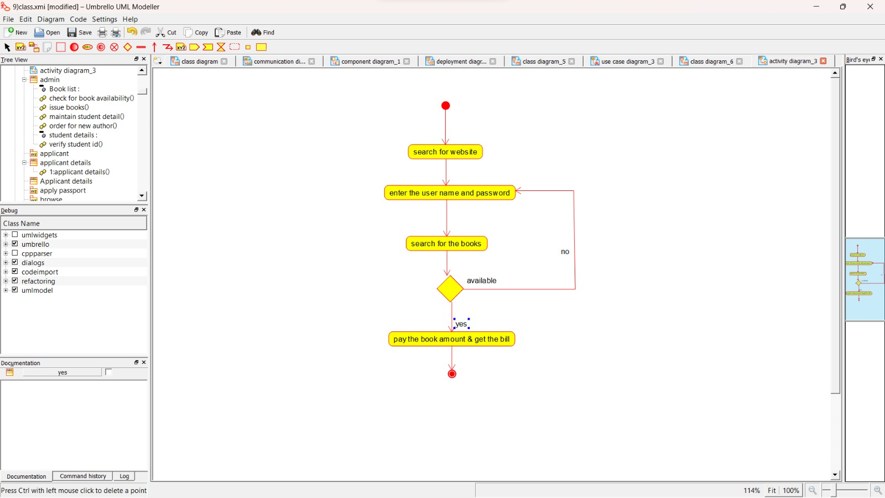

SEQUENCE DIAGRAM:

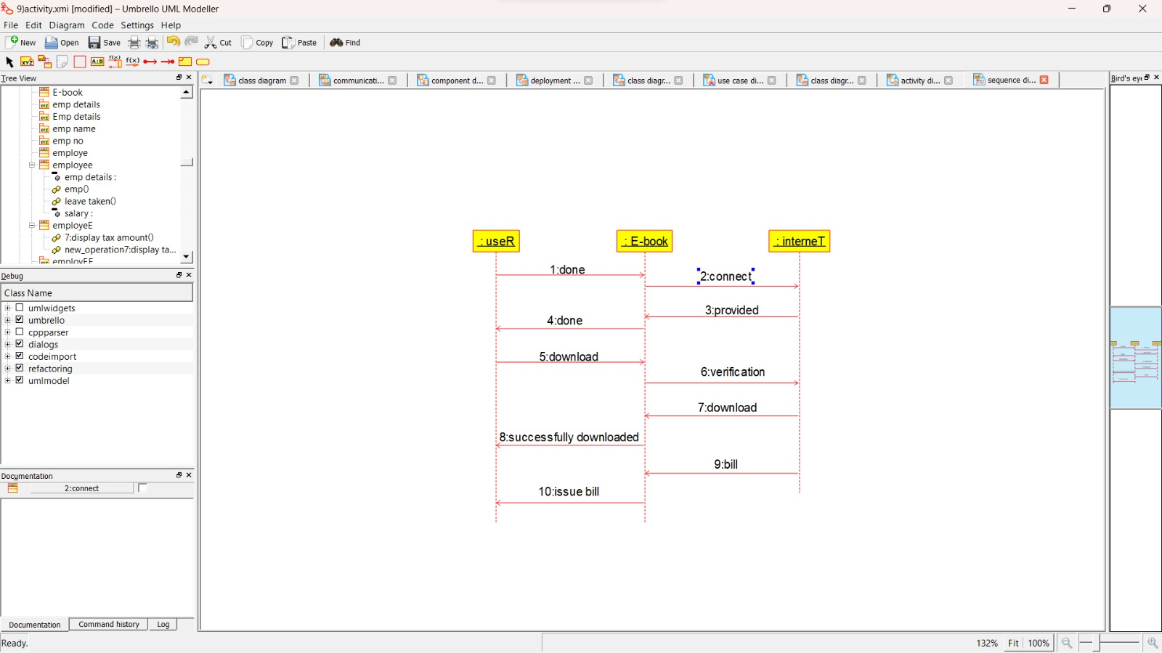

COLLABORATION DIAGRAM:

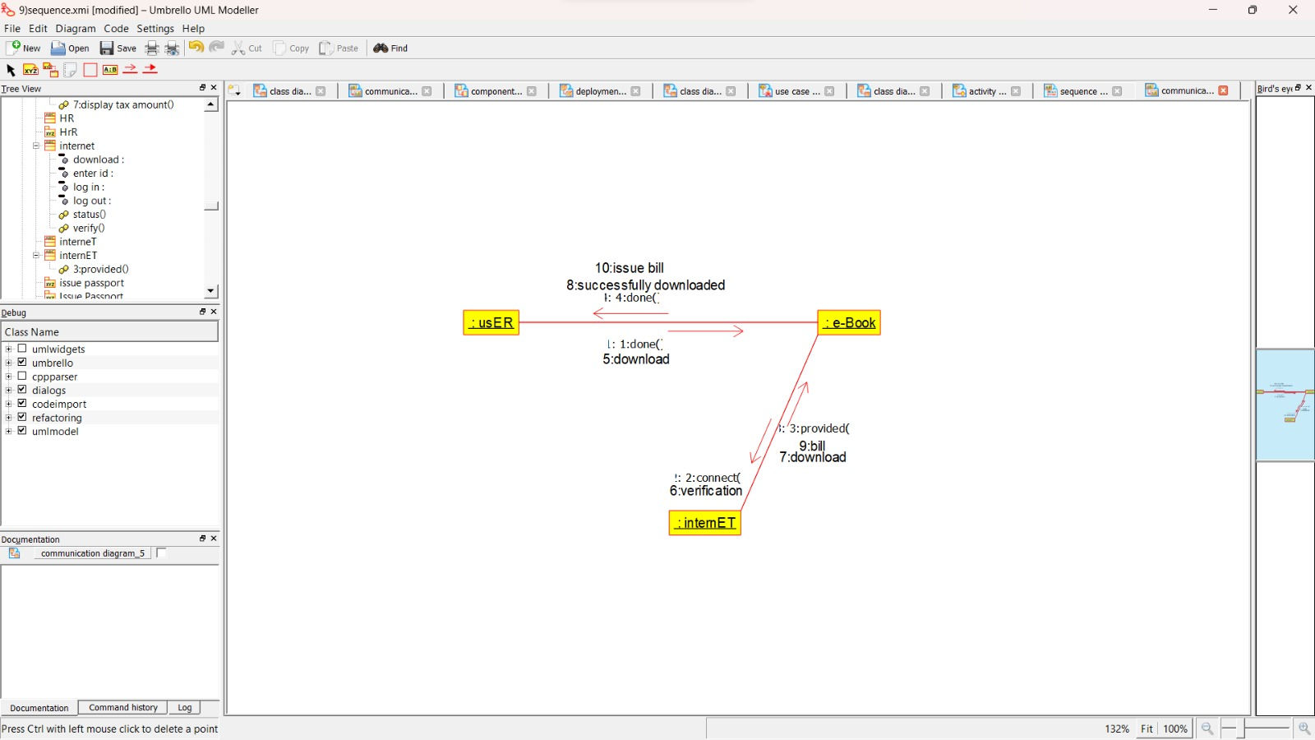

STATE CHART DIAGRAM:

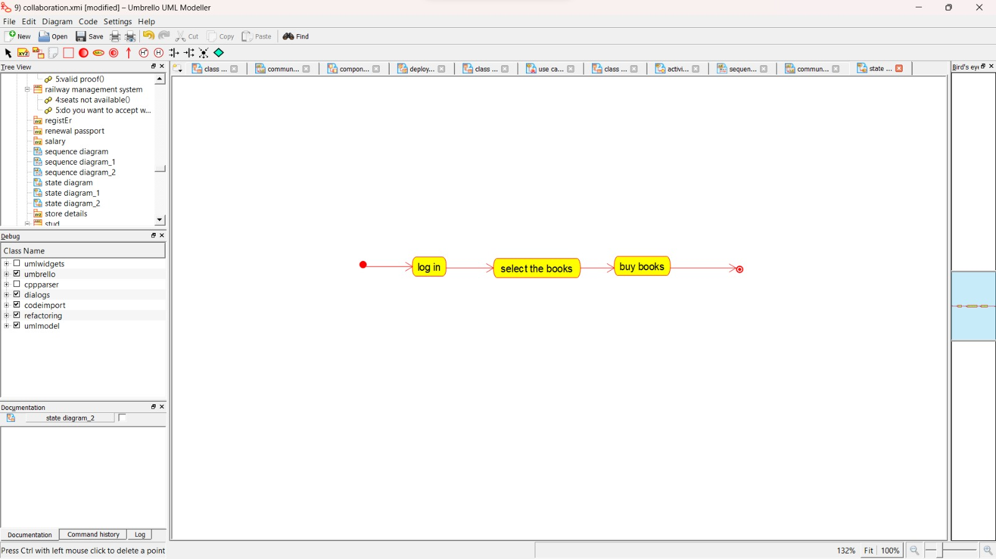

COMPONENT DIAGRAM:

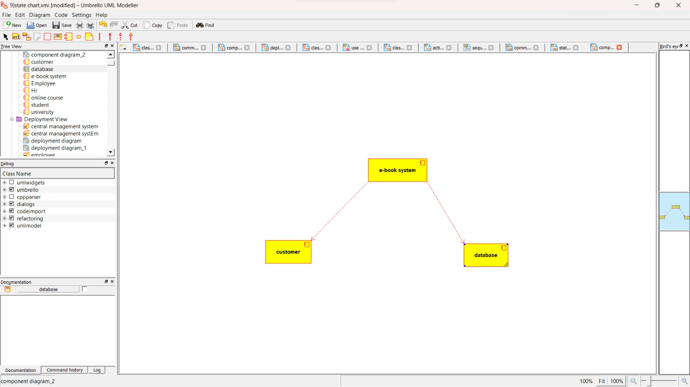

DEPLOYMENT DIAGRAM:

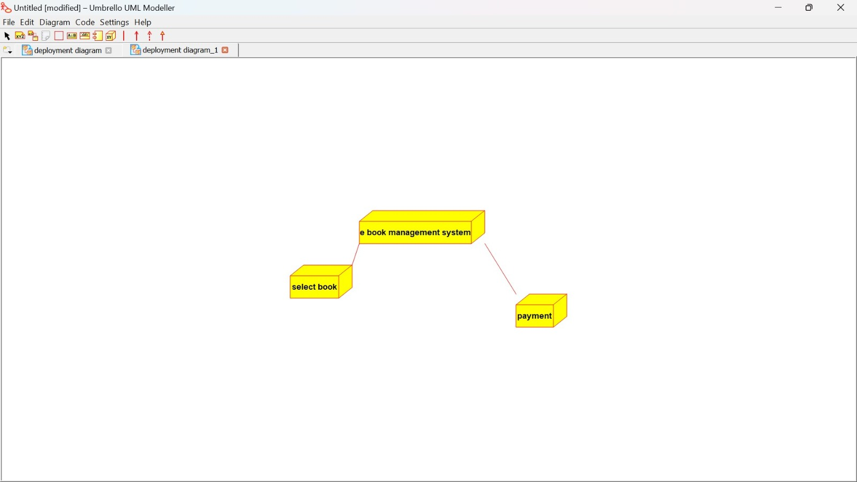

PACKAGE DIAGRAM:

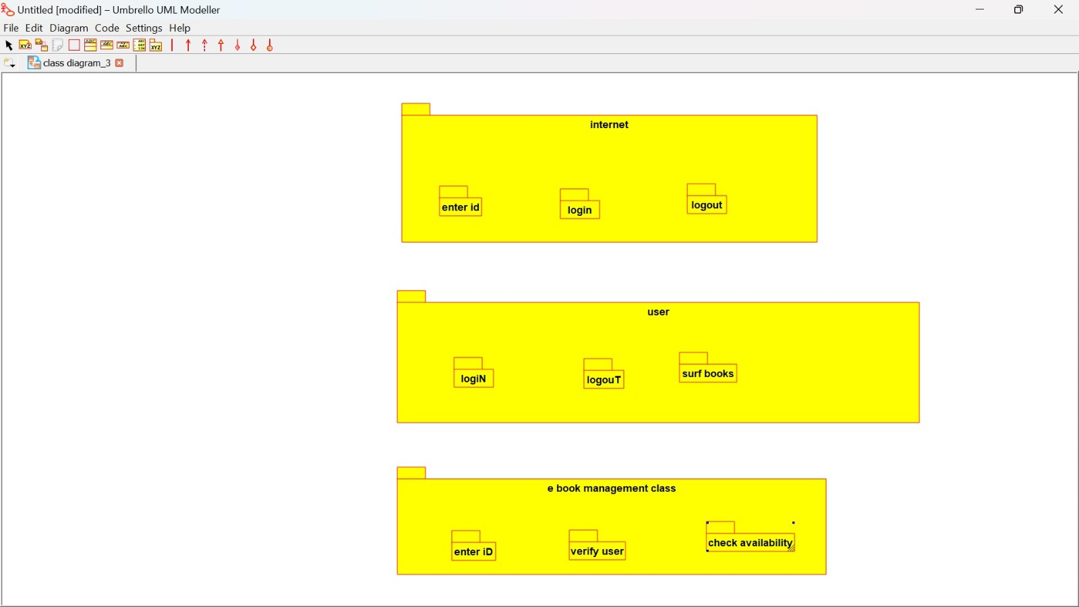

4:RECRUITMENT SYSTEM

USE CASE DIAGRAM:

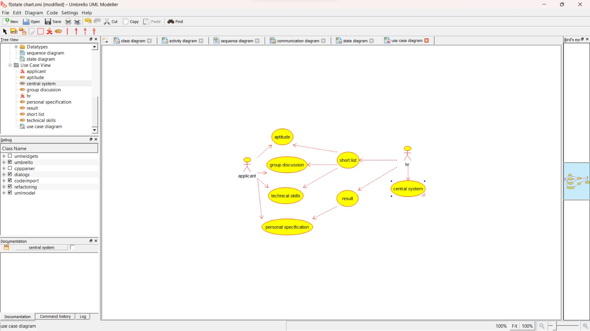

CLASS DIAGRAM:

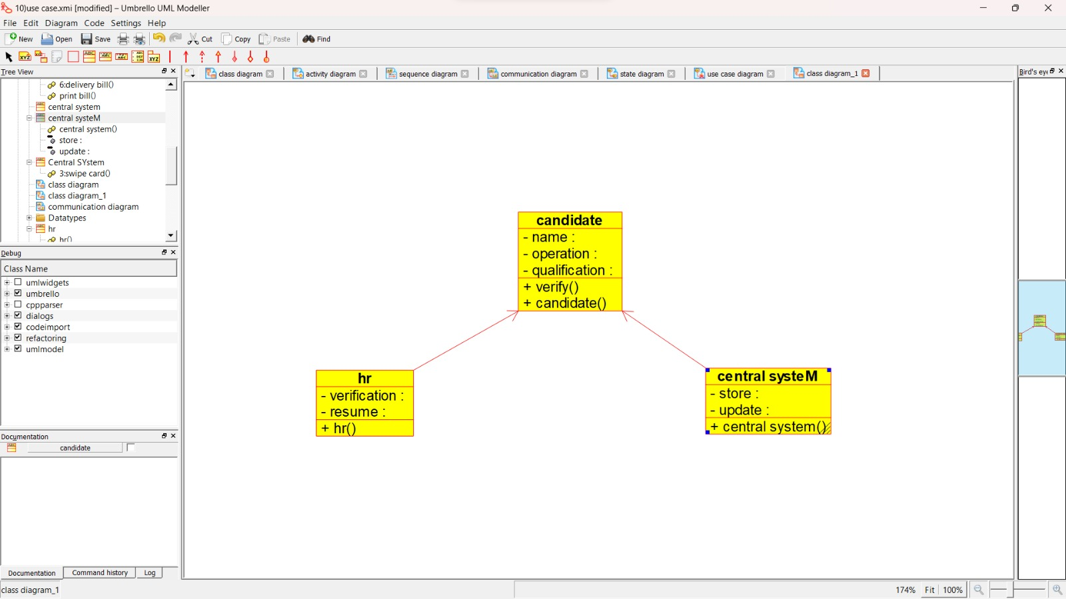

ACTIVITY DIAGRAM:

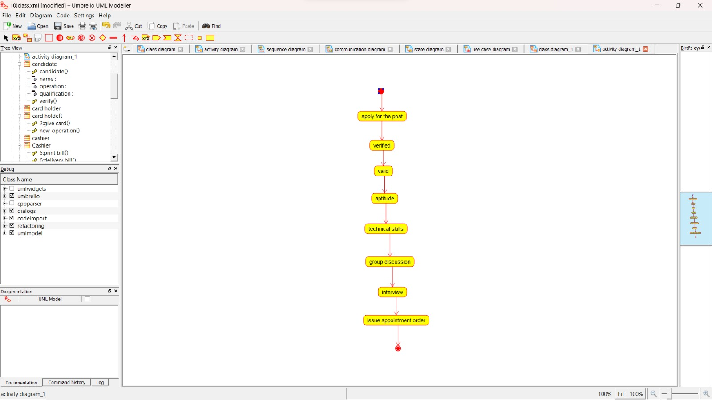

SEQUENCE DIAGRAM:

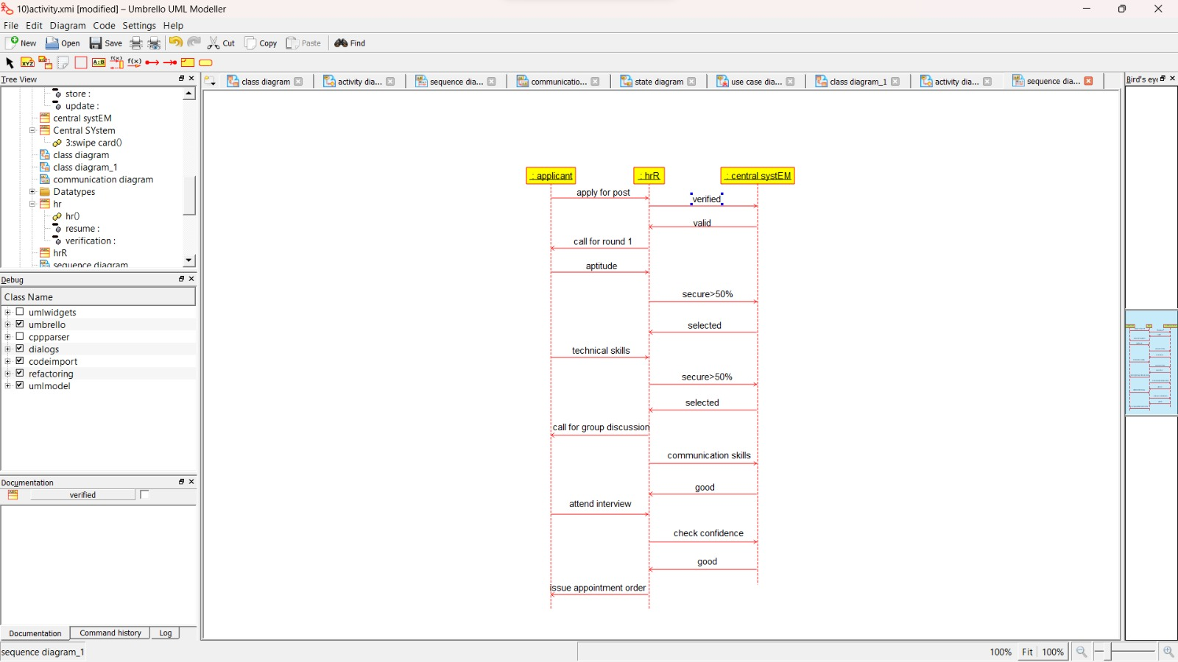

COLLABORATION DIAGRAM:

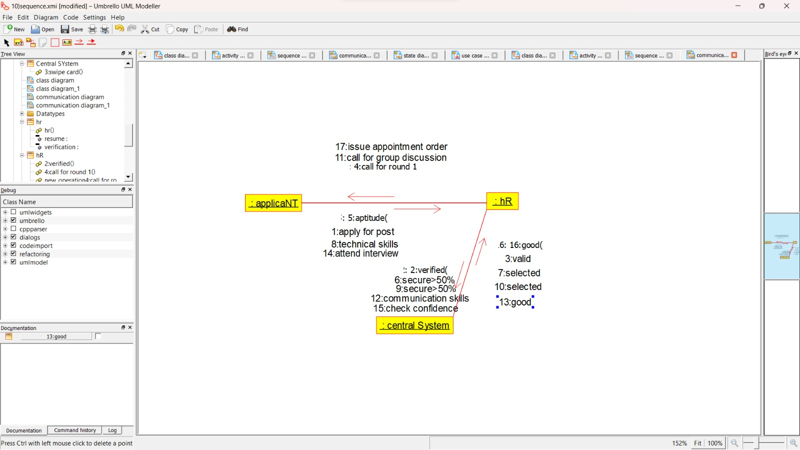

STATE CHART DIAGRAM:

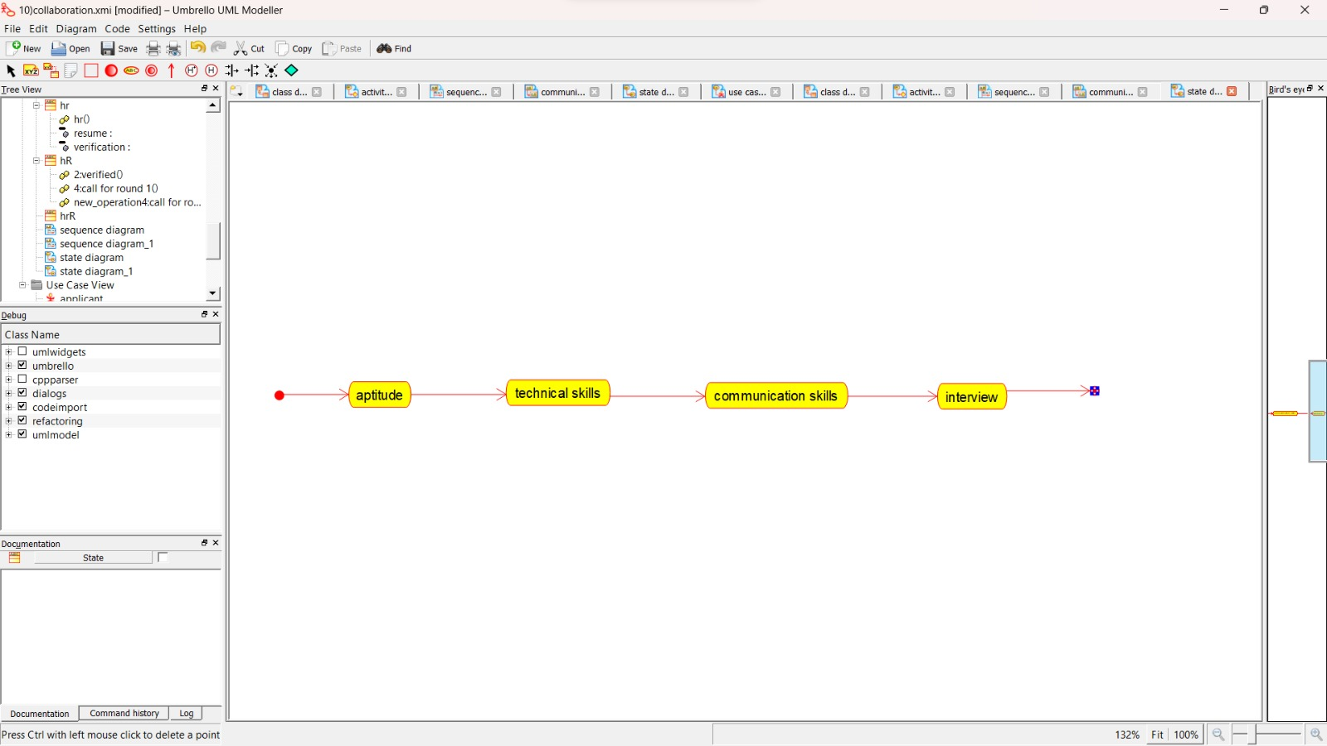

COMPONENT DIAGRAM:

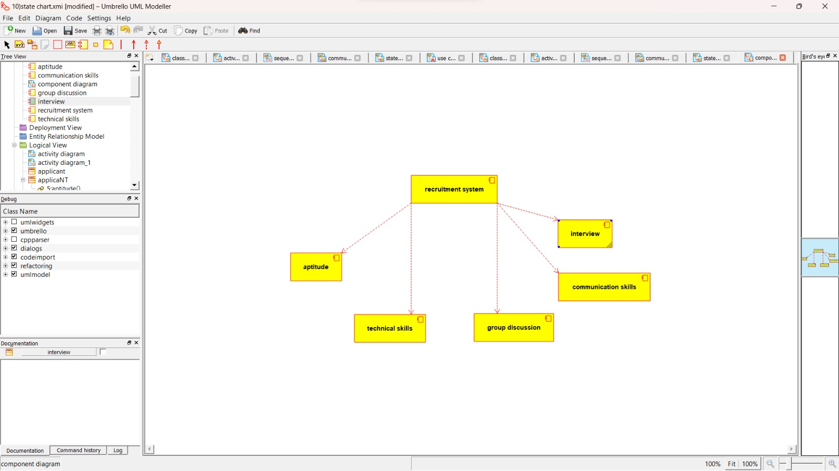

DEPLOYMENT DIAGRAM:

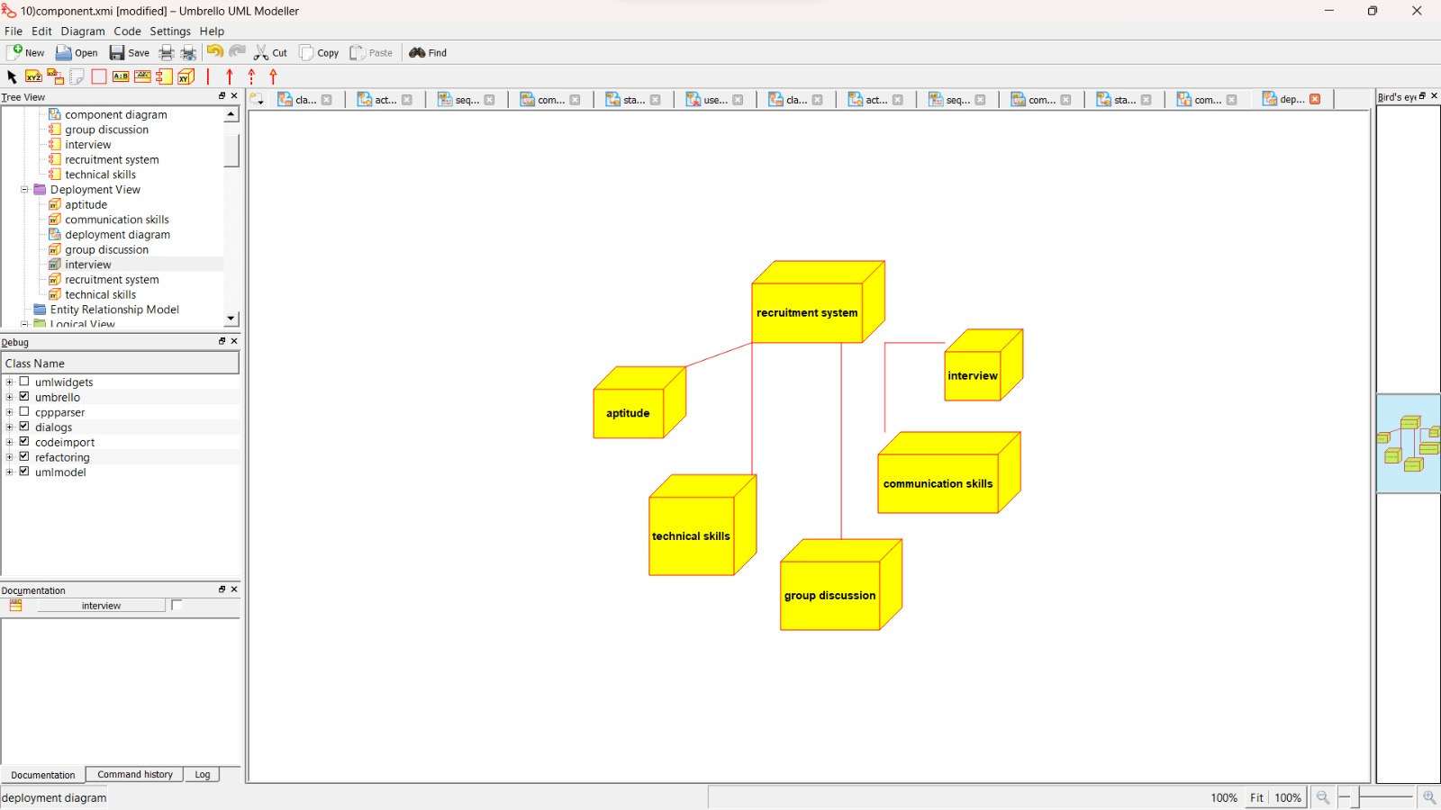

PACKAGE DIAGRAM:

